A. You are given array $a$ of size $n$ you need to print all elements of this array $a$
Input
The first line contains one number $n$ ($1≤n≤{10}^{5}$) the size of the array.
The second line contains $n$ numbers $a_{i}$ ($1≤a_{i}≤{10}^{9}$).
Output
print the elements of this array $a$
Examples
InputCopy | OutputCopy
4  1 3 8 1 | 1 3 8 1
Answer:
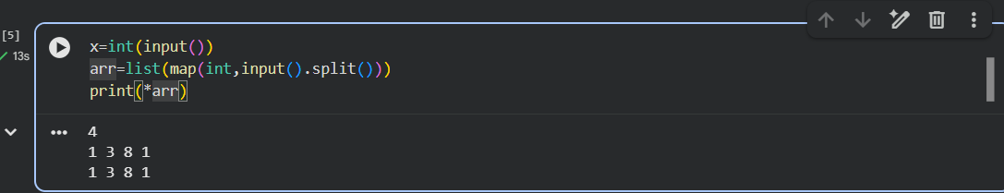

B. You are given array $a$ of size $n$ you need to print the summation of this array's elements
Input
The first line contains one number $n$ ($1≤n≤{10}^{5}$) the size of the array.
The next line contains $n$ numbers $a_{i}$($1≤a_{i}≤{10}^{9}$) the elements of the array $a$
Output
Print one number the answer of the problem
Examples
InputCopy | OutputCopy
5  1 7 8 20 12 | 48
Answer:
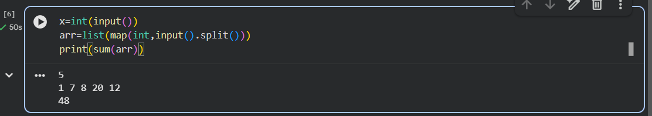

C. You are given an array $a$ of size $n$ and one number $x$ you need to find if $x$ has existed in the array $a$ or not.
Input
The first line contains one number $n$ ($1≤n≤{10}^{5}$) the size of the array.
The second line contains $n$ numbers $a_{i}$ ($1≤a_{i}≤{10}^{9}$) the elemets of the array $a$
The third line contains one number $x$($1≤x≤{10}^{9}$).
Output
Print "Yes" if $x$ exists in array $a$
otherwise print "No"
Examples
InputCopy | OutputCopy
4  4 8 1 9  1 | Yes

InputCopy | OutputCopy
4  4 2 1 9  8 | No
Answer:
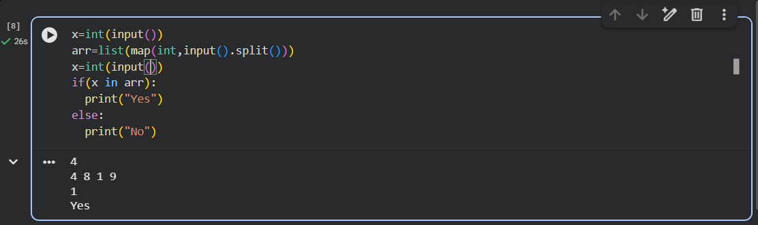
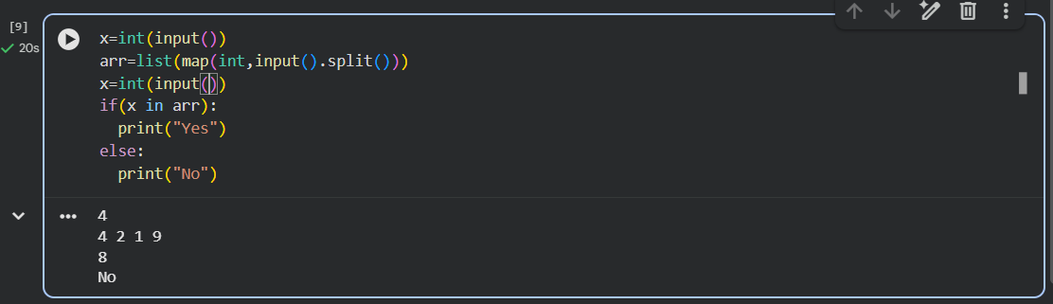
D. You are given an array $a$ of size $n$ and you need to find the Maximum element in this array and it's index in (0-based)
Input
The first line contains one number $n$ ($1≤n≤{10}^{5}$) the size of the array $a$.
The next line contains $n$ number $a_{i}$ ($1≤a_{i}≤{10}^{9}$) the elemnts of array $a$.
Output
Print the maximum element of this array $a$ and it's index in (0-based).
Examples
InputCopy | OutputCopy
6  8 1 88 19 20 5 | 2
Answer:

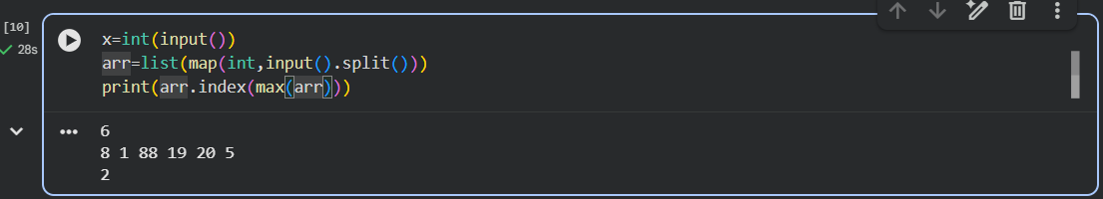

E. You are given array $a$ of size $n$ you need to print the index of the minimum element of this array
Note:
- The index in $0$-based form.
- If the minimum number more than once print the index in the first time you met
.
Input
The first line contains one number $n$ ($1≤n≤{10}^{4}$).
The second line contains array elements $a_{i}$ ($1≤a_{i}≤{10}^{12}$).
Output
print the answer of this problem
Examples
InputCopy | OutputCopy
5  3 1 8 9 4 | 1

InputCopy | OutputCopy
3  1 2 1 | 0
Answer: 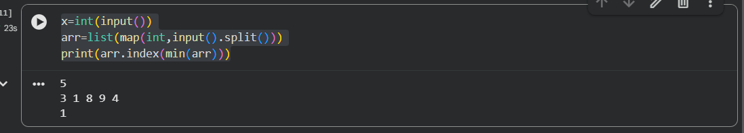
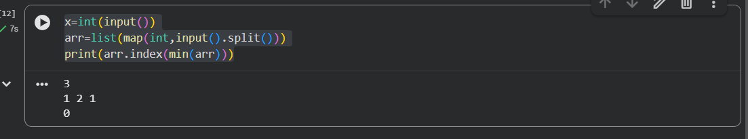

F. You are given array $a$ of size $n$ to determine if array $a$ palindrome or not!
Note: If you need to know what palidrome is
Input
The first line contains one number $n$ ($1≤n≤{10}^{4}$) the size of the array $a$.
The second line contains array $a$ elements $a_{i}$ ($1≤a_{i}≤{10}^{6}$).
Output
Print "Yes" if array $a$ is palindrome.
otherwise print "No".
Examples
InputCopy | OutputCopy
5  1 2 3 2 1 | Yes

InputCopy | OutputCopy
5  1 2 3 4 5 | No
Answer: 